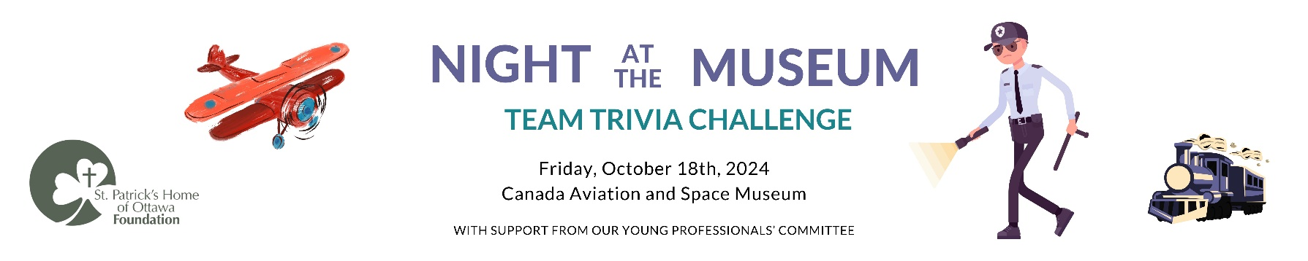
SILENT AUCTION – CONFIRMATION FORM
Contact: _______________________________________Title: __________________________________________

Company: ______________________________________________________________________________________

Address: ________________________________________________________________________________________
City: _______________________________ Province: _______________ Posta Code: ______________________
Phone Number: ____________________________ Email: _________________________________

Your company will be recognized on the auction table, auction signage, and on social media posts before the Night at the Museum event.

- We would like to contribute an item or package for your silent auction.
- Please contact me for pick-up I will drop it off at St. Pat’s I will mail it to you by October 7th, 2024

Item Description: ______________________________________________________________________________
Value: $ ____________

Please send your completed form to foundation@stpats.ca or by mail at the address below.

THANK YOU FOR SUPPORTING
ST. PATRICK’S HOME OF OTTAWA FOUNDATION AND THE PEOPLE IN OUR CARE!

