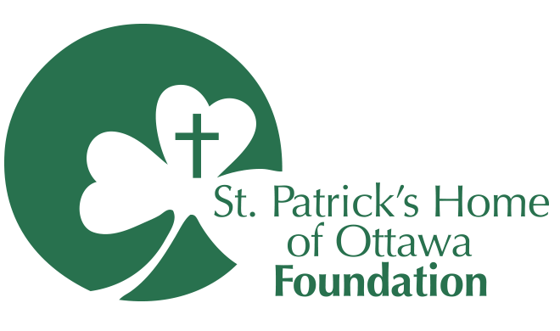
APPLICATION
for appointment to the Board of Directors

Thank you for your interest in serving as a member of the Board of Directors for St. Patrick’s Home of Ottawa Foundation. Please introduce yourself by answering the following questions and providing a copy of your C.V. (if current / relatively current).

Completed applications may be sent to Breanne Case, Development Coordinator, by email at BreanneCase@stpats.ca. Applications are due by September 14, 2021, and will be reviewed by the Governance and Nominating Committee on September 21, 2021.

Contact Information

Name:
Address:
Preferred Telephone Number:
Email Address:

Key Questions

- Please outline your professional profile and/or involvement with community projects or organizations including but not limited to:

- Employment with a nonprofit organization
- Volunteer work with a Committee or Board of Directors of a nonprofit organization
- Fundraising as a member of a committee or campaign cabinet
- Other related experience.

- What is your knowledge of, or personal experience with St. Patrick’s Home of Ottawa and/or its Foundation?

- What values, attributes or services related to St. Patrick’s Home are important to you as a potential member of the Foundation’s Board of Directors?

The link to the vision, mission and values that guide St. Patrick’s Home is here: https://stpats.ca/about-us/vision-mission-values/ and the Foundation’s website is here: https://stpatsfoundation.ca

- Why are you interested in joining the Board of Directors of St. Patrick’s Home of Ottawa Foundation?

- If not answered above, what expertise, competencies, industry sector representation, and/or interest in providing local seniors and vulnerable persons with quality long-term care would you bring to the Board?

